EXPERIMENT 1

1.1 PROGRAMS
1.1.1 #Area of circle
ALGORITHM :
Step 1 : Start
Step 2 : Input Radius
Step 3 : Calculate area of circle
Area = 3.14 * radius * radius
Step 4: Display Area
Step 5 : Stop

FLOWCHART: 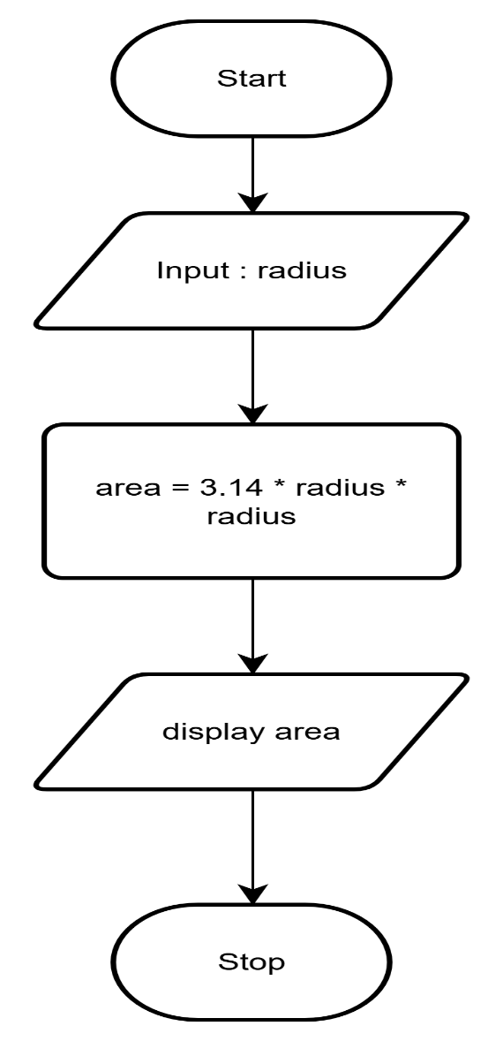

CODETANTRA:
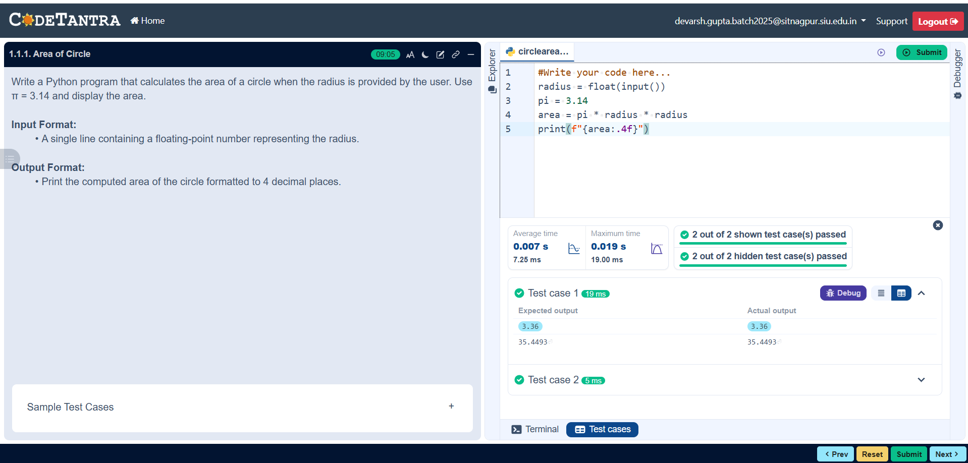

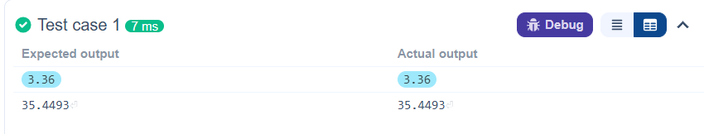

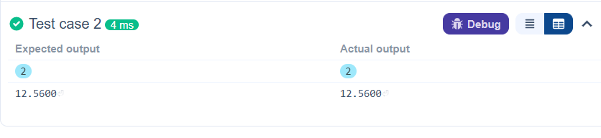

1.1.2# Area Of a Rectangle
ALGORITHM:
Step 1: Start
Step 2: Input length and width
Step 3: Calculate the Area of Rectangle
Area = Length * Width
Step 4: Display Area
Step 5: Stop
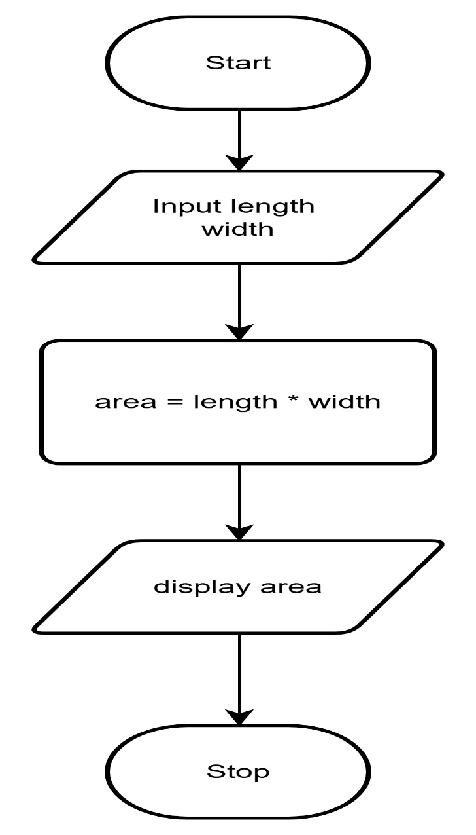
FLOWCHART

CODETANTRA:
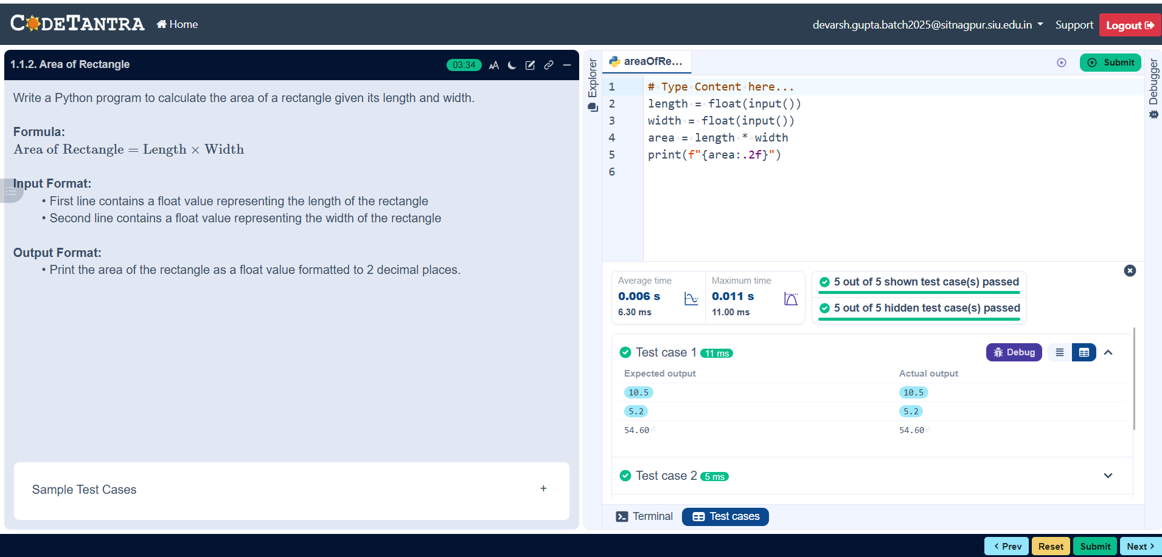
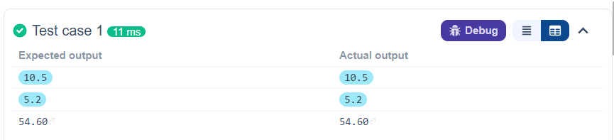
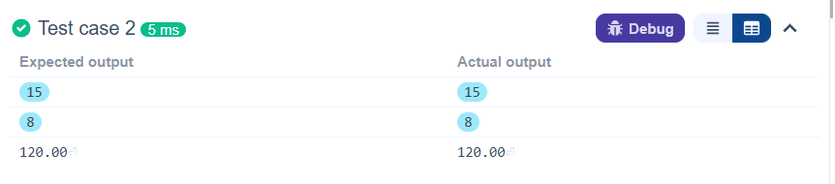
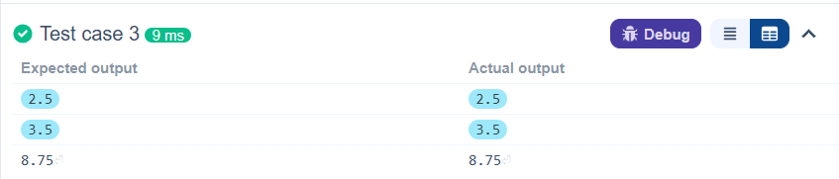

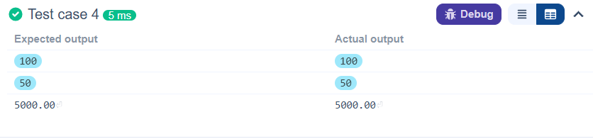

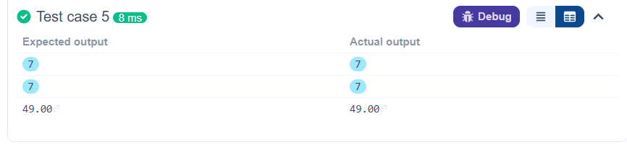

1.1.3 Area of Square
ALGORITHM:
Step 1: Start
Step 2: Input side
Step 3: Calculate the Area of Rectangle
Area = side * side
Step 4: Display Area
Step 5: Stop
FLOWCHART:

PTO
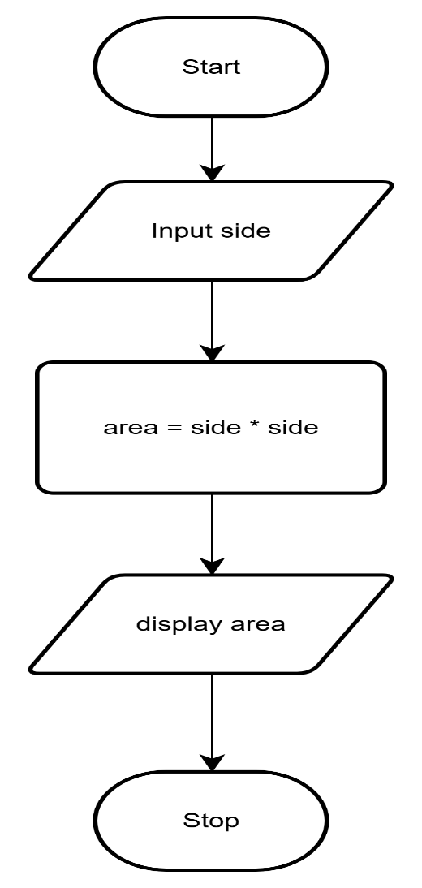

CODETANTRA:
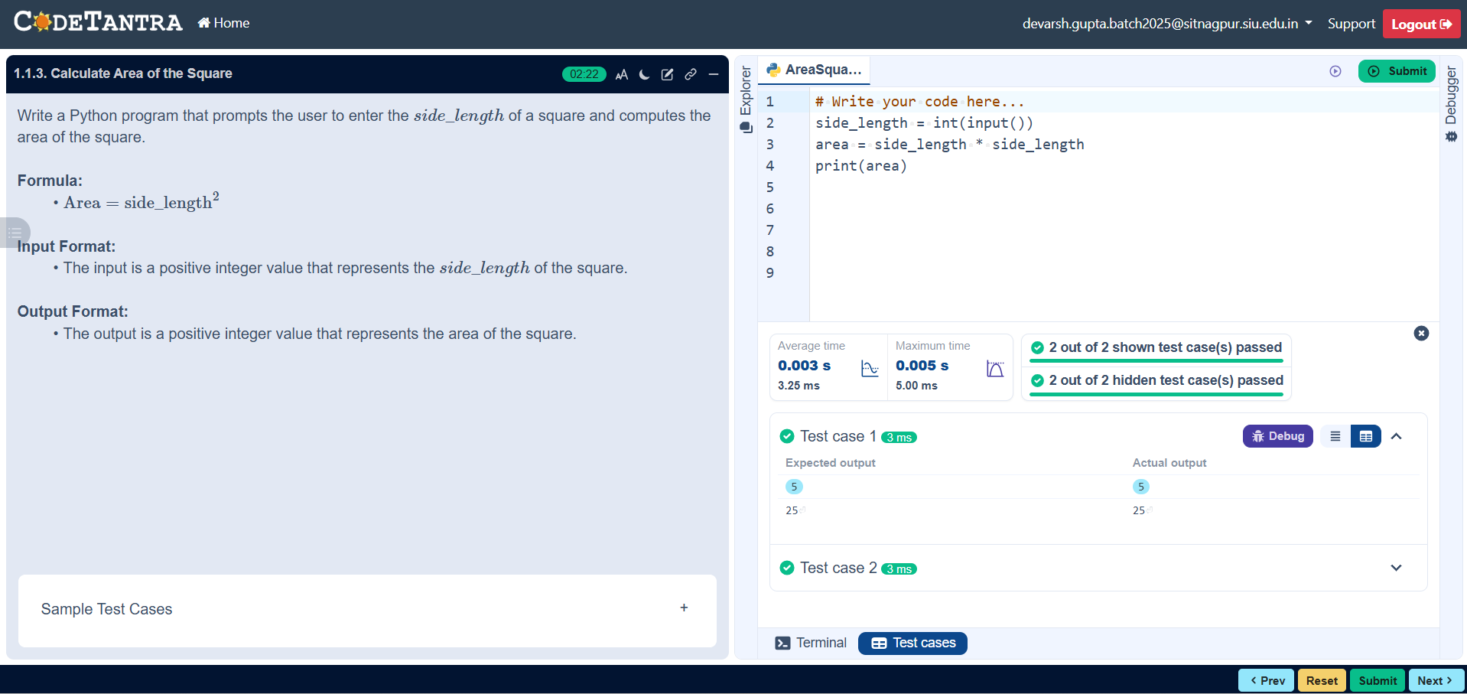
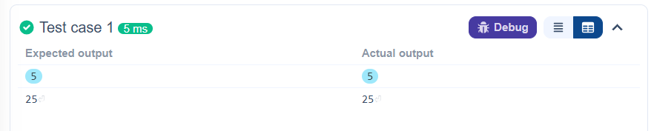
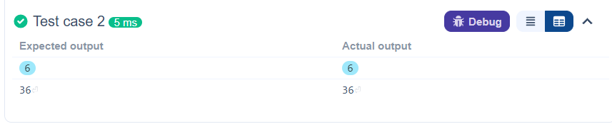
1.1.4 Area of Triangle
ALGORITHM:
Step 1: Start
Step 2: Input base and height
Step 3: Calculate area of triangle
Area = 0.5 * base * height
Step 4 : Display area
Step 5 : Stop

FLOWCHART:
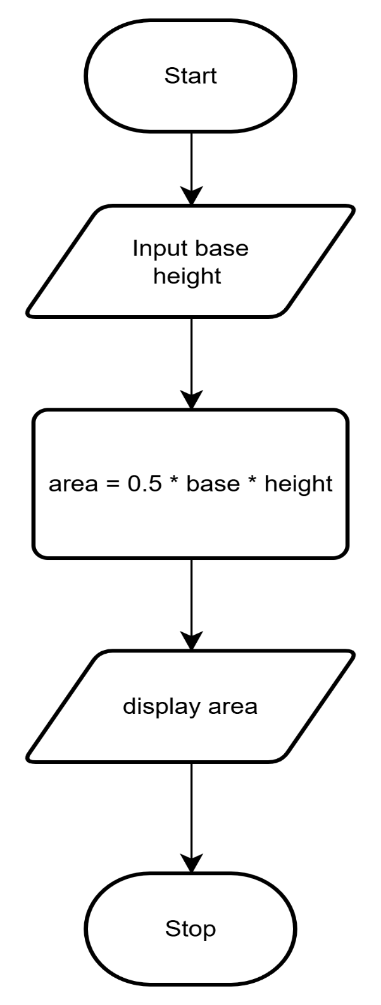
CODETANTRA :
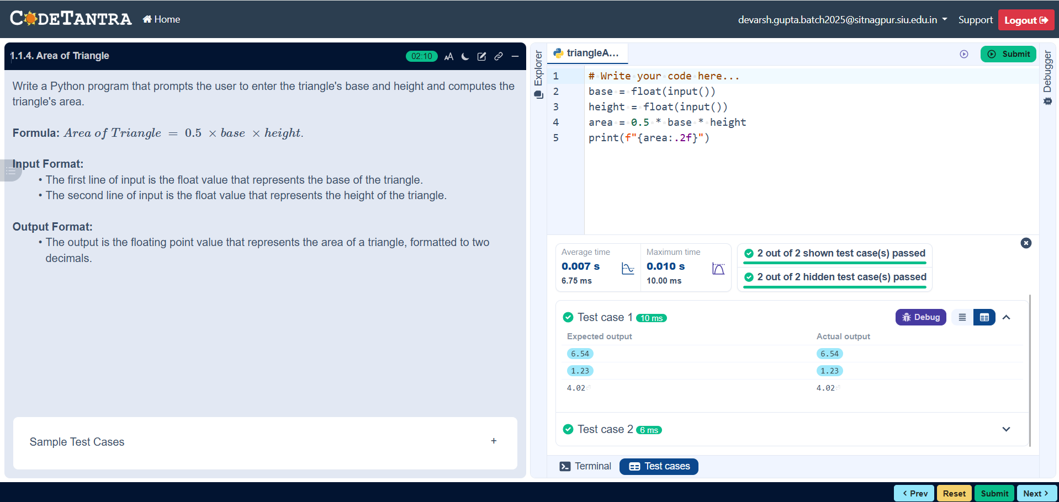
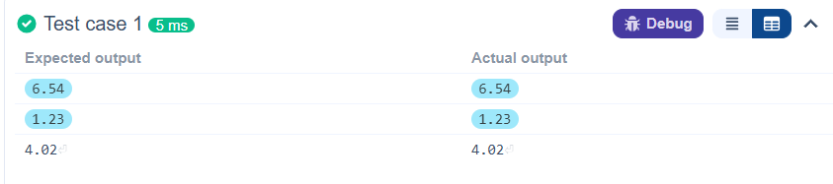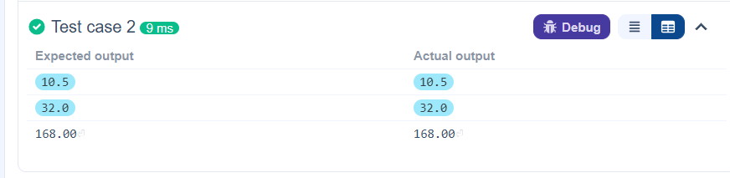

1.1.5 Student Pass or Fail
ALGORITHM:
Step1: Start
Step 2: Read the marks obtained by the student
Step 3: Check if marks ≥ 40
- If yes, print "Pass"
- If no, print "Fail"
Step 4: Stop

FLOWCHART: 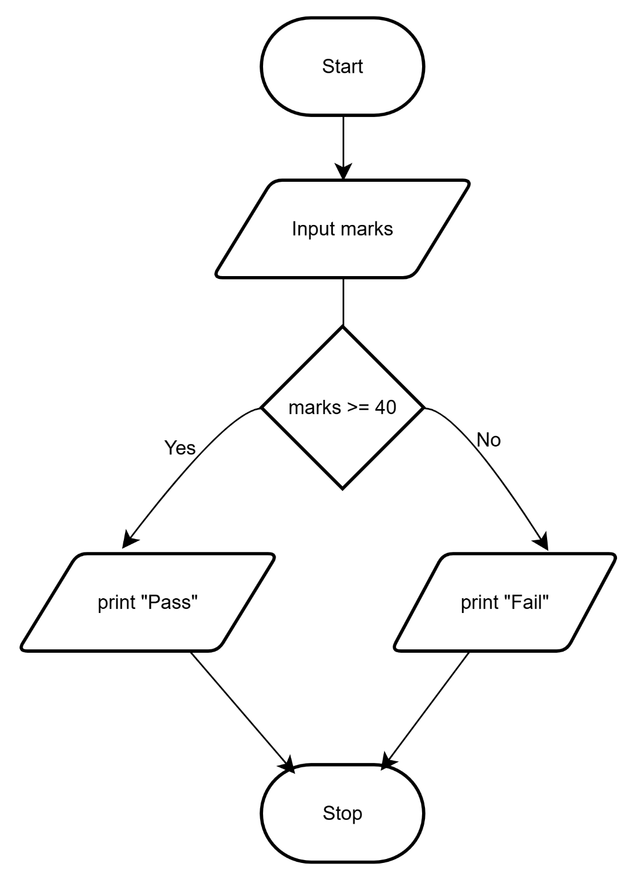
CODETANTRA:
